AI-Powered Email Triage and Task Manager Workflow
Name: Dhruv Chauhan
Student ID: 23064005
Email: dhruv.chauhan.civ23@itbhu.ac.in
Drive Video Links:
https://drive.google.com/file/d/1o9OI4i-k00Oyad4V6uCtS6WSRJ3gYP-A/view?usp=sharing

1. Introduction
Email remains one of the most widely used communication tools in academic and professional environments. However, with the increasing volume of incoming emails, it becomes difficult to identify which messages require action and which are simply informational. Important emails containing tasks such as assignment submissions, reminders, or project updates can easily get buried among routine communications. This often leads to missed deadlines, reduced productivity, and decision fatigue caused by constantly managing the inbox manually.
To address this challenge, we developed an AI-Powered Email Triage and Task Manager using n8n, a low-code workflow automation platform. The objective of this project is to automatically analyze incoming emails, detect whether they contain actionable tasks, extract relevant information such as task description and priority, and create a corresponding task in a task management system like Todoist.
The system integrates Generative AI through the Google Gemini Chat Model, automation workflows in n8n, structured data parsing, and conditional logic to simulate the behavior of a digital assistant that reads emails and converts them into actionable tasks. By combining AI reasoning with workflow automation, the project demonstrates how modern AI agents can improve personal productivity and streamline daily communication management.

2. Workflow Design and AI Agent Implementation
The workflow was implemented using n8n Cloud, which provides a visual node-based environment where each node performs a specific operation. The workflow automatically triggers when a new email arrives and processes the message through several stages before creating a task.
The entire system consists of a sequence of interconnected nodes that work together to analyze and process emails efficiently.
Workflow Node Sequence
1. Email Trigger (IMAP)
The Email Trigger node monitors the connected inbox using the IMAP protocol. Whenever a new unread email arrives, the workflow is triggered automatically. The node retrieves metadata including the email subject, sender, and body content, and forwards it to the next step in the workflow. After successful processing, the email is marked as read.
2. Code Node (JavaScript)
Emails often contain HTML formatting, signatures, and previous conversation threads that may confuse the AI model. Therefore, a JavaScript Code Node is used to preprocess the email data. This script removes HTML tags, unnecessary formatting, and irrelevant text sections so that the AI receives clean plain-text input.
This preprocessing step improves the accuracy of the AI model by ensuring that it focuses only on the relevant email content.
3. Basic LLM Chain with Google Gemini Chat Model
This node acts as the intelligence center of the workflow. The cleaned email text is passed to the Google Gemini Chat Model, which analyzes the message and determines whether it contains an actionable task.
The AI agent performs two main operations:
- Intent Classification: Determine whether the email contains a task.
- Data Extraction: Extract the task description and estimate its priority.
The AI is instructed through a carefully designed prompt to return the result strictly in JSON format.
AI Prompt Used
You are an expert Email Triage Agent. Your job is to analyze the user's email and determine if it contains a clear, actionable task.

If an actionable task exists:
- Extract the Task Content
- Assign a Priority (High, Medium, Low)
- Set TaskStatus = "TASK_FOUND"

If no task exists:
- Set TaskStatus = "NO_TASK"

Return the output strictly as JSON:

{
"TaskStatus": "TASK_FOUND or NO_TASK",
"TaskContent": "Task description",
"Priority": "High / Medium / Low"
}
This structured prompt ensures that the AI produces a consistent and machine-readable output.

4. Structured Output Parser
AI models sometimes generate responses with inconsistent formatting. The Structured Output Parser node enforces the required JSON schema so that downstream nodes can reliably interpret the output fields.
This guarantees that the workflow receives clean structured data.

5. If Node (Conditional Logic)
The If Node acts as a decision-making filter in the workflow.
- If TaskStatus = TASK_FOUND, the workflow proceeds to task creation.
- If TaskStatus = NO_TASK, the workflow stops.
This prevents unnecessary task creation and ensures only actionable emails are processed further.

6. Todoist Node – Create Task
When a task is detected, the workflow reaches the Todoist Create Task Node. This node automatically generates a new task inside a specified Todoist project.
The task includes:
- Task title extracted from the email
- Priority level determined by the AI model
- Optional additional metadata
Todoist requires numeric priority values, so a small JavaScript mapping converts AI labels into numbers:
- High → 4
- Medium → 3
- Low → 2

3. Testing and Validation
To evaluate the performance of the workflow, several different email scenarios were tested.
Email Subject | Detected Task | Priority | Result
Urgent: Submit Project Report by 5 PM | Submit project report | High | Task Created
Action Required: Prepare Presentation Slides | Prepare slides for demo | High | Task Created
Reminder: Update Learning Journal | Update weekly journal | Low | Task Created
FYI: Meeting Notes | None | None | No Task Created
The workflow successfully distinguished between informational and actionable emails and created tasks with the correct priority levels in Todoist.

4. Challenges and Solutions
During development, several technical challenges were encountered.
1. Email Data Quality
Emails often contain signatures, quoted replies, and unnecessary formatting that can confuse the AI model.
Solution:
JavaScript preprocessing was implemented to remove HTML tags and irrelevant content.

2. Inconsistent AI Output
Initially, the AI sometimes returned plain text instead of JSON.
Solution:
The Structured Output Parser and strict prompt instructions ensured consistent JSON output.

3. Data Flow Issues
In some cases, the workflow nodes could not properly access the AI output fields.
Solution:
Direct JSON path expressions were used to retrieve values from the parser node.

4. Priority Mapping
Todoist requires numeric priority values while the AI produces textual labels.
Solution:
A JavaScript expression converted priorities dynamically during task creation.

5. API Credential Configuration
Setting up IMAP authentication, Gemini API access, and Todoist project IDs required careful configuration.
Solution:
n8n's Credential Manager was used to securely store and manage authentication details.

5. Conclusion and Future Improvements
The AI-Powered Email Triage and Task Manager successfully demonstrates how artificial intelligence and automation can work together to simplify email management.
By integrating the Google Gemini Chat Model, n8n automation workflows, and Todoist task management, the system acts as an intelligent digital assistant capable of:
- Reading emails
- Identifying actionable tasks
- Assigning priorities
- Automatically creating tasks
This significantly reduces manual effort, prevents important emails from being overlooked, and improves productivity.
Future Improvements
Several enhancements could further improve the system:
- Automatic Email Acknowledgment: Send confirmation emails after tasks are created.
- Due Date Extraction: Detect phrases like “by Wednesday” and assign deadlines automatically.
- Context-Based Priority: Use sentiment or urgency detection to refine priority levels.
- Integration with Slack or Microsoft Teams: Notify users about high-priority tasks instantly.
- Performance Analytics: Track email processing statistics and AI accuracy over time.
Overall, this project demonstrates a practical real-world implementation of an AI Agent capable of reasoning, decision-making, and tool orchestration. It highlights the potential of AI-driven automation in improving productivity and managing digital communication effectively.
ScreenShots:
n8n Canvas Workflow
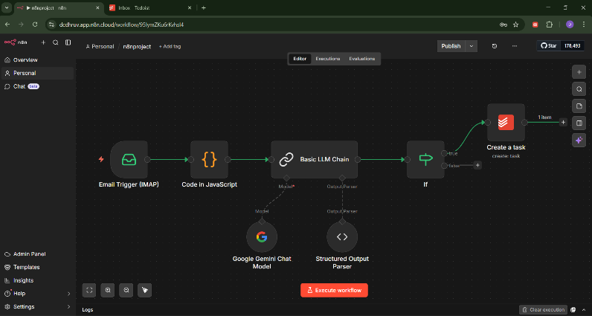
Email Trigger (IMAP)
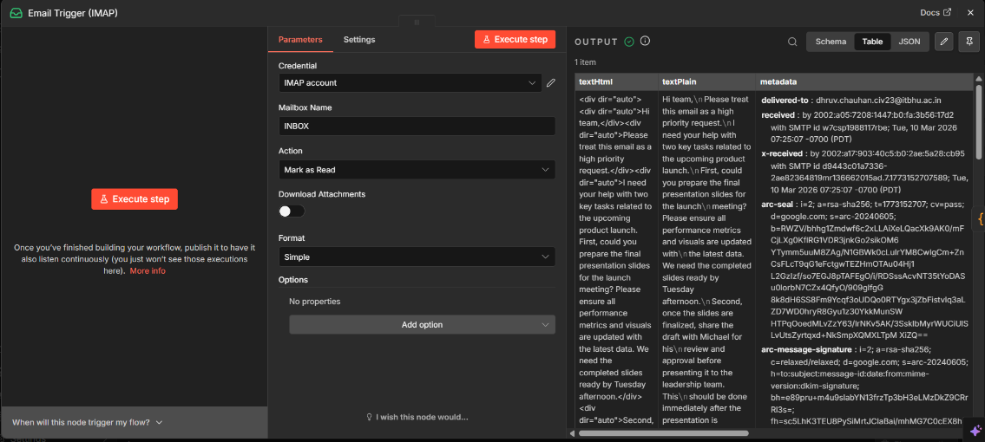

Code in JavaScript
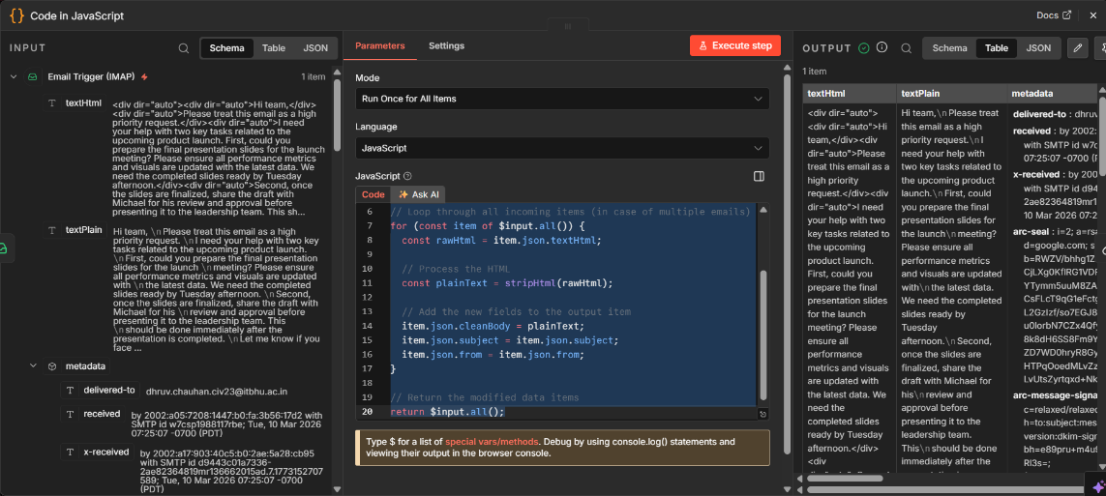

Basic LLM Chain
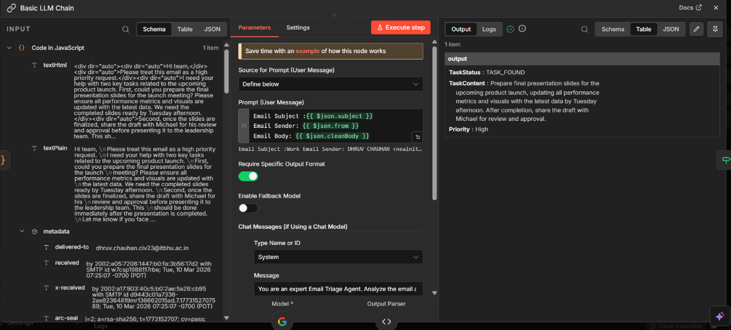

Google Gemini Chat model
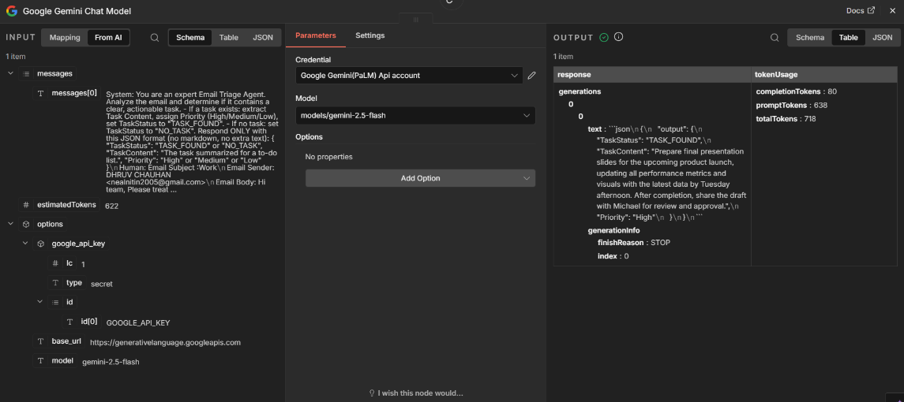

Structured Output Parser
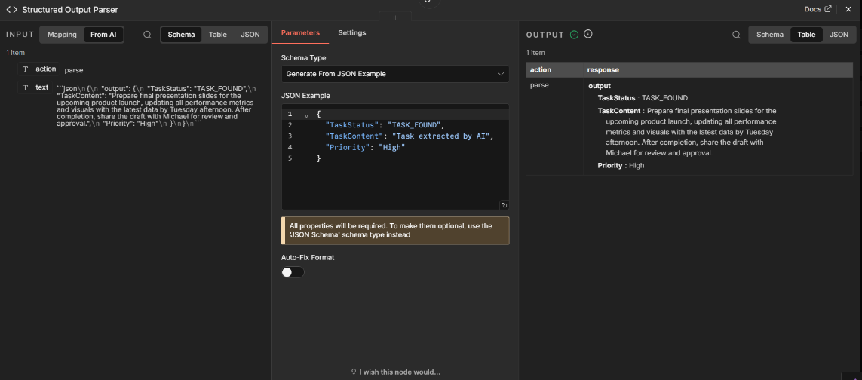

If Node
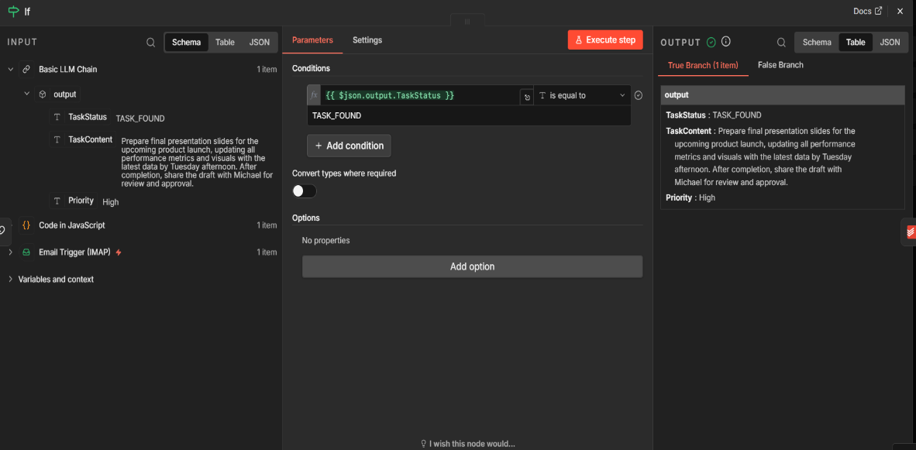

Todoist (Create a Task)
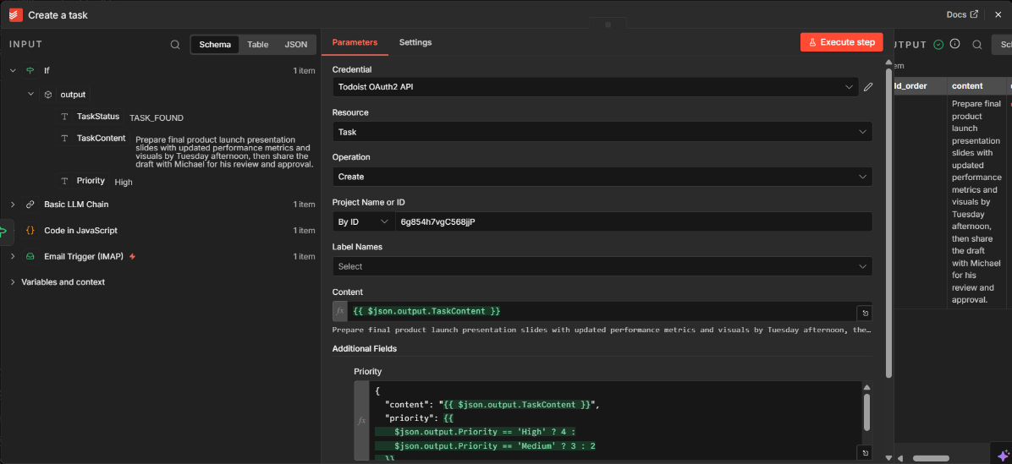

Todoist Task assigned
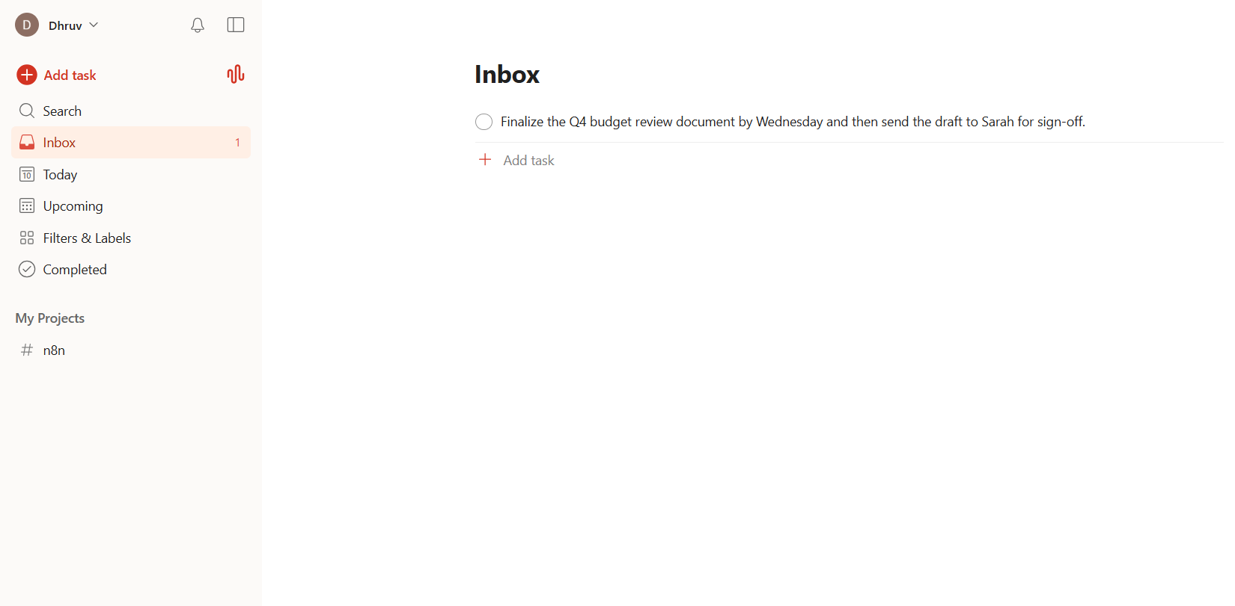

Unread Email
